[Mall] I händelse av brand – In case of fire
Detta dokument är framtaget som en mall för att kunna användas av brandskyddsansvariga vid framtagande av informationsmaterial och rutin för utrymning i händelse av brand på engelska.
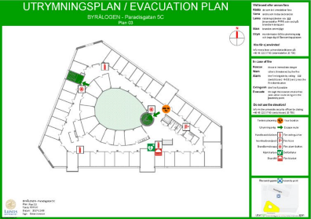
Information about evacuation routes, the location of fire extinguishers, fire alarm buttons and assembly points can be found on the evacuation plans strategically placed in all buildings at Lund University.
Study the evacuation plans in advance so that you are prepared in case you need to evacuate the building!
How to act in case of a fire depends on the situation. Here you will find general information on what to do.

Rescue
Save people who are in immediate danger – help each other!
Remember your own safety; do not expose yourself to unnecessary risks.

Alert
Alert those around you that a fire has started or that the fire alarm has gone off.
Urge the people around you to start evacuating. Remember that people listening to music on their headphones may not have heard the alarm.
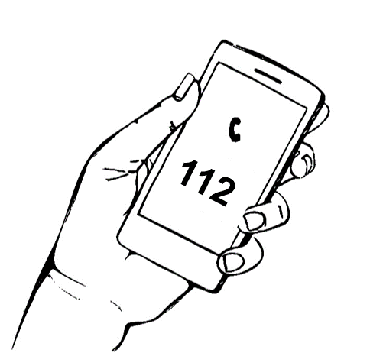
If the alarm does not automatically start, or if there is another cause for evacuation, press the alarm buttons placed throughout the building.

Raise the alarm
Call the emergency services via SOS Alarm by dialing 112 (or 0-112 if you are calling from within the University) and answer the operator’s questions. Calling 112 enables the right resources to be sent to the location at an early stage.
The address of this building is: XXXXX
If possible, also inform the University security control centre at +46 46-222 07 00. The security officer can help you in an evacuation and initiate Lund University’s crisis procedure when necessary.

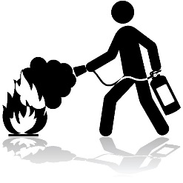
Extinguish
All fires start small – acting quickly makes a big difference.
Extinguish the fire if you think you can do so, but remember your own safety – do not expose yourself to unnecessary risks!

Evacuate
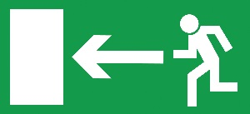
Evacuate the building via the nearest smoke-free evacuation route and head for the assembly point.
Close any doors behind you to minimise the spread of fire and smoke.
Lifts must never be used for evacuation!
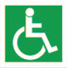
If you are in the middle of teaching, make sure to evacuate together with your group via the nearest smoke-free evacuation route.
Does anyone need help evacuating? The stairwells in this building, XXX, constitute safe zones in case of a fire. In such places, known as evacuation sites, people with reduced mobility or orientation can await help from the emergency services.

Once you have evacuated
Go to the assembly point!
If you have information about what happened in the building, e.g. that there are still people inside or where the fire is located, it is important that you notify the evacuation officer, University security officer or the emergency services staff directly.
Just because the alarm is switched off, it does not necessarily mean that the danger is over. The emergency services may silence the alarm to facilitate their work in the building. Therefore, never return to the building before receiving permission from the emergency services, the University security officer or the person in charge of the building.

Shortcomings in fire safety
If you discover any shortcomings in fire safety, please contact the fire safety manager XXXX
Shortcomings in fire safety can be things like defective fire extinguishers, blocked evacuation routes or damaged evacuation signs.
Find out about the fire safety rules in the building! You will find the rules here: XXXX

